
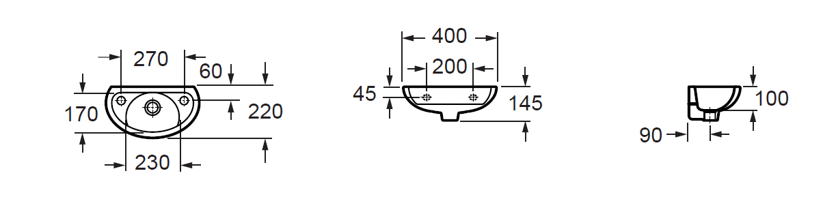
Ferrara 400mm Wall basin
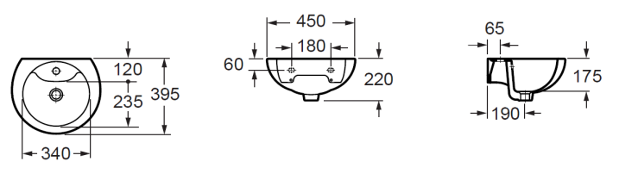
Ferrara 450mm Wall Basin
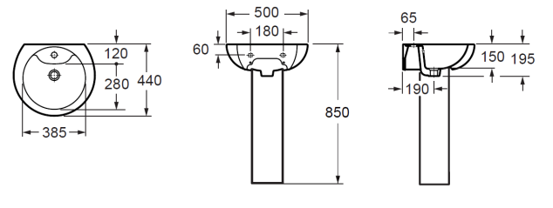
Ferrara 500mm Wall basin & Pedestal
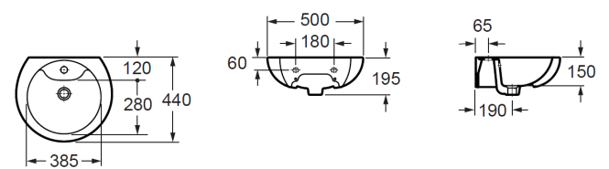
Ferrara 500mm Wash Basin
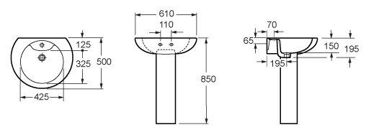
Ferrara 610mm Wash Basin Pedestal
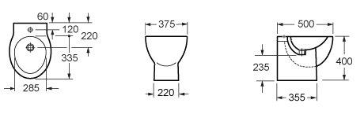
Ferrara Floor Bidet
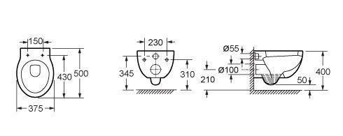
Ferrara Wall Hung WC Pan
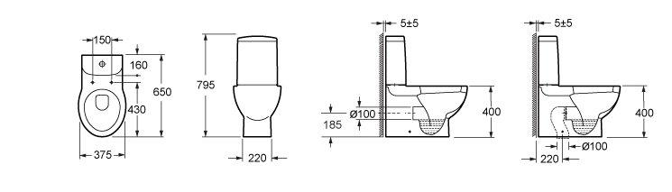
Ferrara WC Pan Cistern
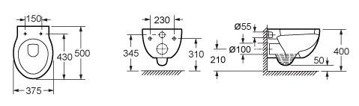
Wall Hung Dims
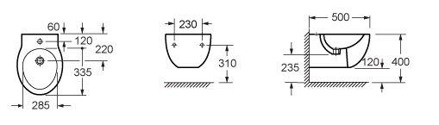
Wall Hung WC Dims

